Building block of Redux

Store

Actions

Reducers

Store: A single JS object that contains the **state** of the application. We can think of it as client side database.

Actions: A plain JS objects that represent something that has happened. Think of it as event.

Reducers: A pure function that specifies how the state changes on action. Think of it as event handler. A reducer does not modify the state it returns new state than the store will internally update the state

Reducers are pure function

Difference between pure and impure functions

A pure function does not modify its argument should return same output whenever called with same input

function increment(input){

input.count++; // impure function as it is changing the argument value

return input.count++

}

function increment(input){

return { count: input.count+1 }

}

Reducer

function reducer(state, action){

// typically a reducer takes state and action, based on action type it **return new state** without modifying current state

Case ‘INCREMENT’:

return { count: state.count + 1}

}

Three principles of REDUX ARCHITECTURE

1. Single source of truth
2. State is read-only
3. Pure functions update state

Single source of truth

1. One state tree inside Store

REDUX ARCHITECTURE

Single State Tree:

Plain JavaScript Object e.x – const state = { todos: [] }

Composed by reducers

Actions:

Two properties

Type: string describes event

Payload: optional data

Dispatch actions to reducers

Ex: const action = {

Type: ‘ADD_TODO’,

Payload:{}

}

Reducers: Pure functions

Responds to action.type

Access to action.type

Compose new state

Return new state

Example

function reducer(state,action){

switch(action.type){

case ‘ADD_TODO’:{

const todo = action.payload;

const todos = […state.todos, todo]

return { todos }

}

}

Return state;

}

Store is nothing but state container

Components interact with the store

Subscribe to slices of state

Dispatch actions to the store

Store invokes reducers with previous state and Action

Reducers compose new state

Store is updated, notifies subscribers

**Just for Joke: Component is like a client, store is like a vendor company and reducers are developer**

**Client gives requirement to vendor, vendor sends this requirement ot developer developer makes product and send back to vendor and vendor sends it to client**

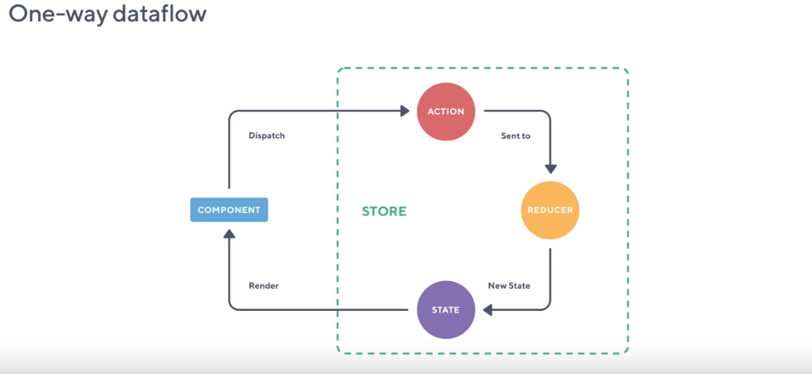

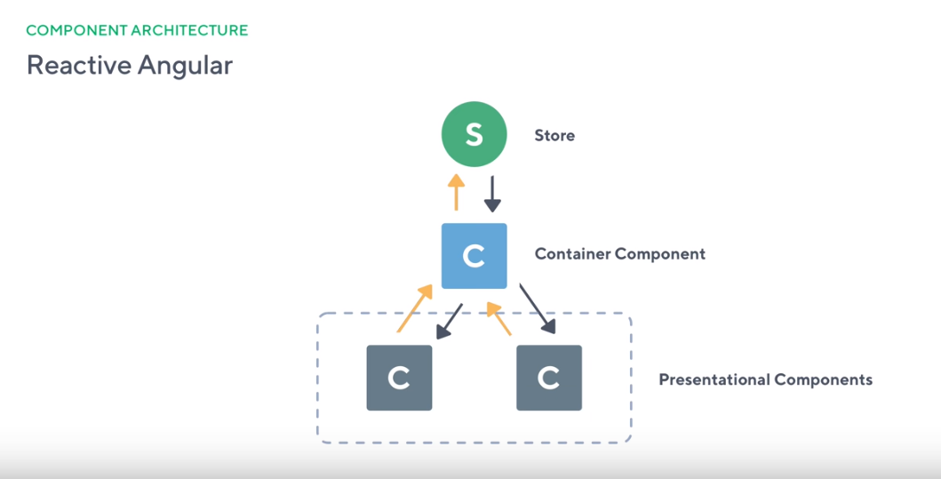

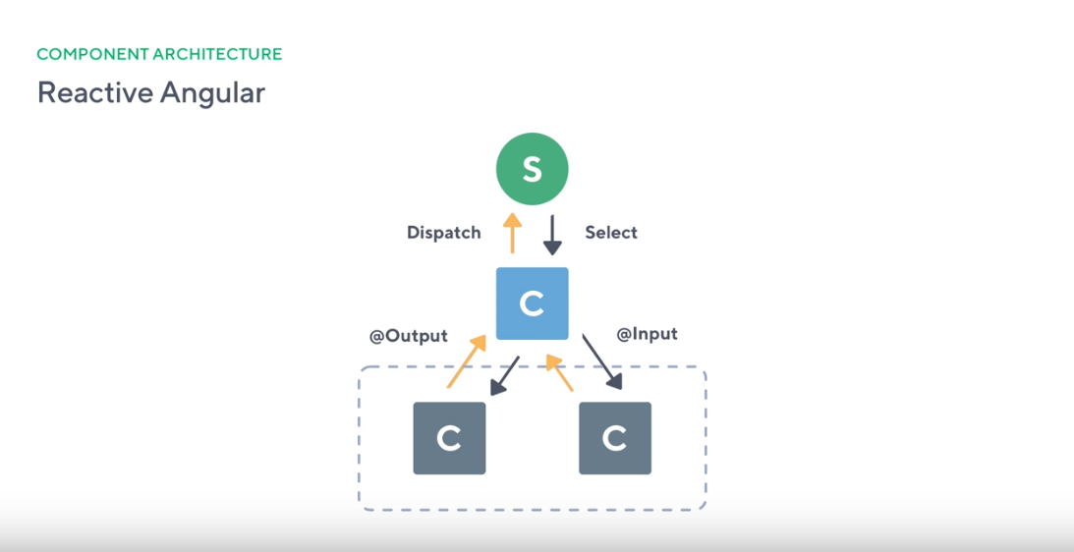

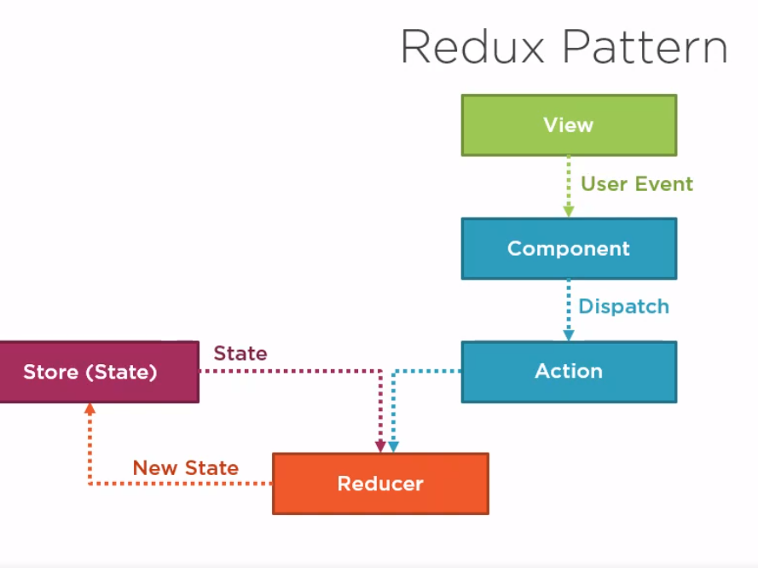

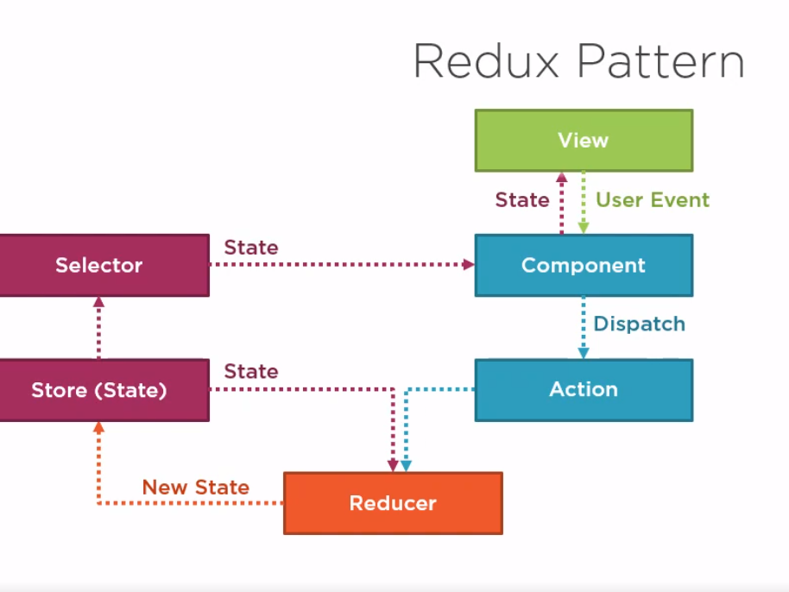

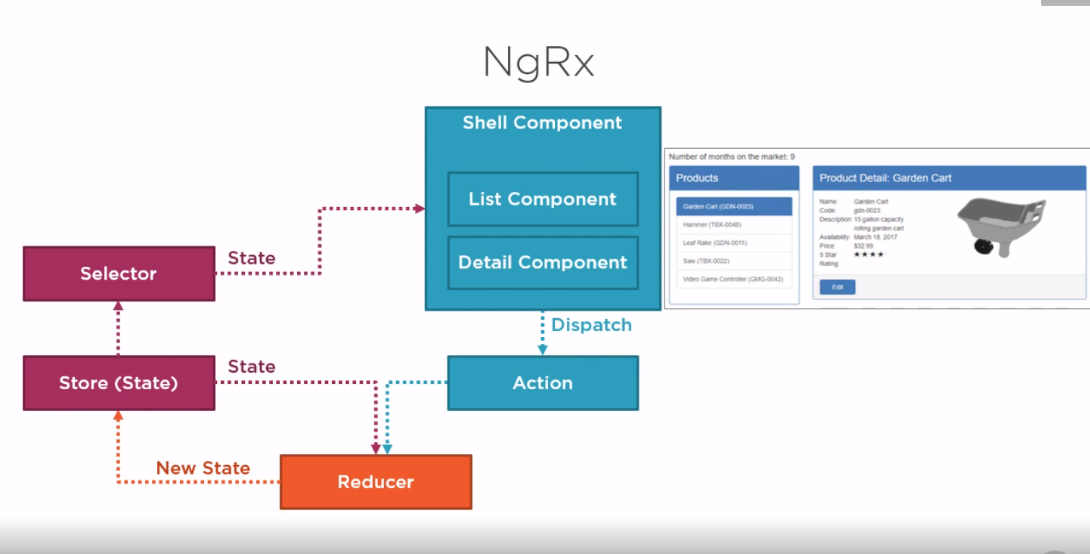

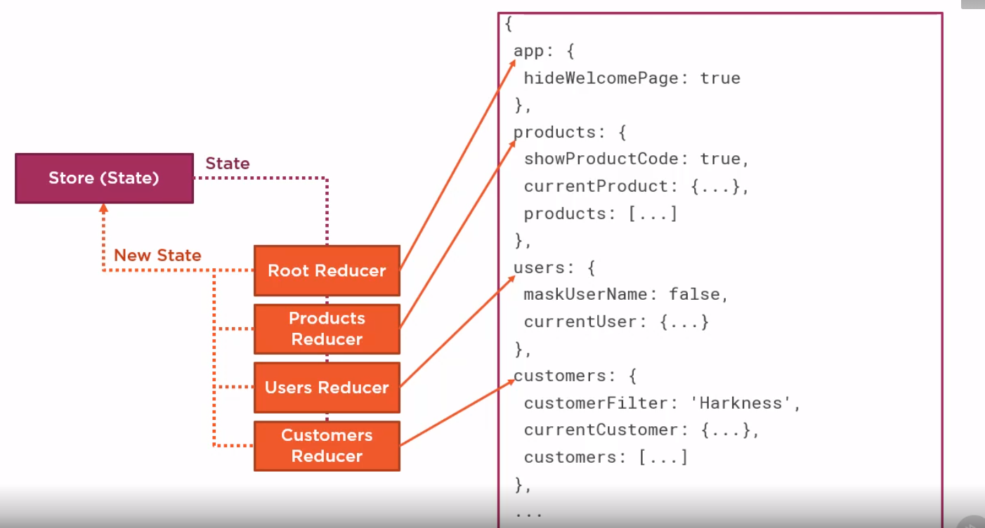

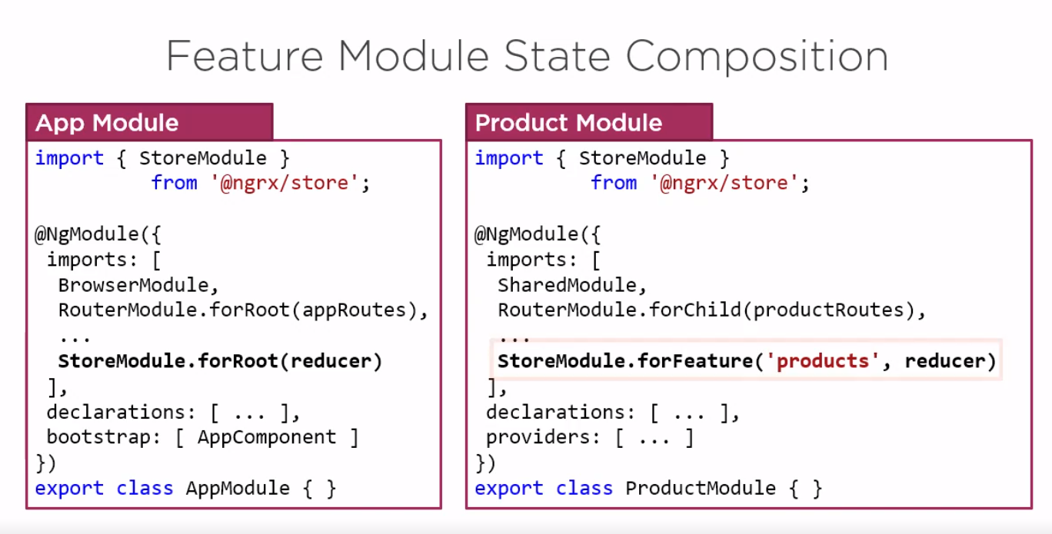

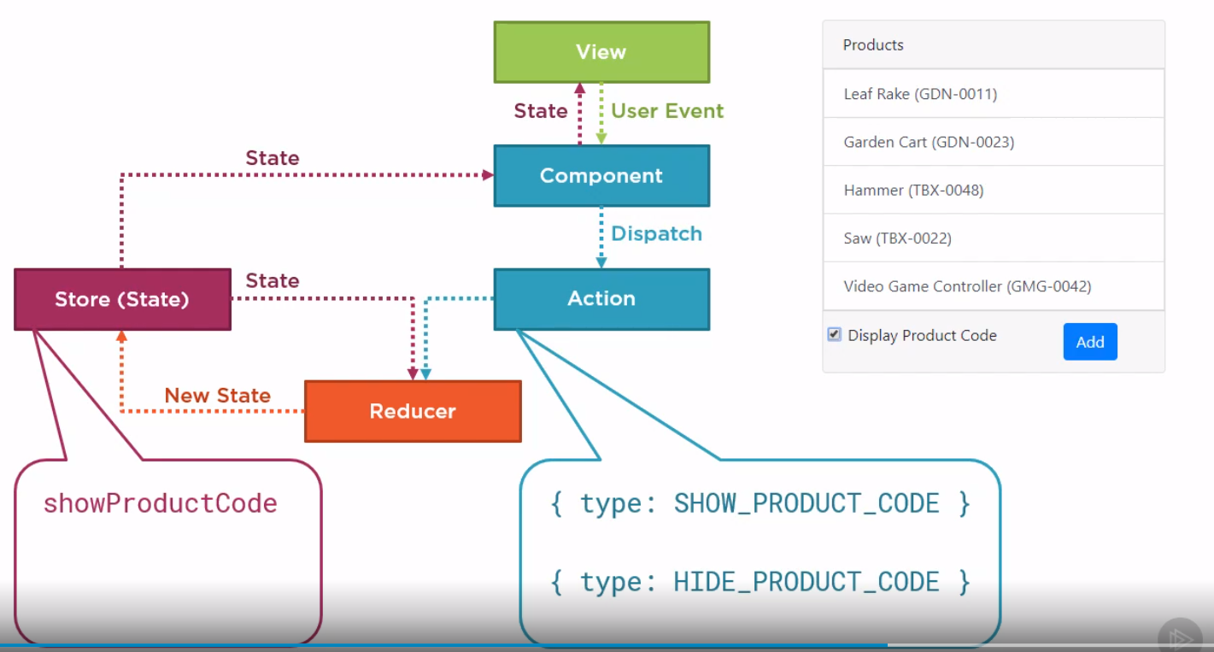

**OR**

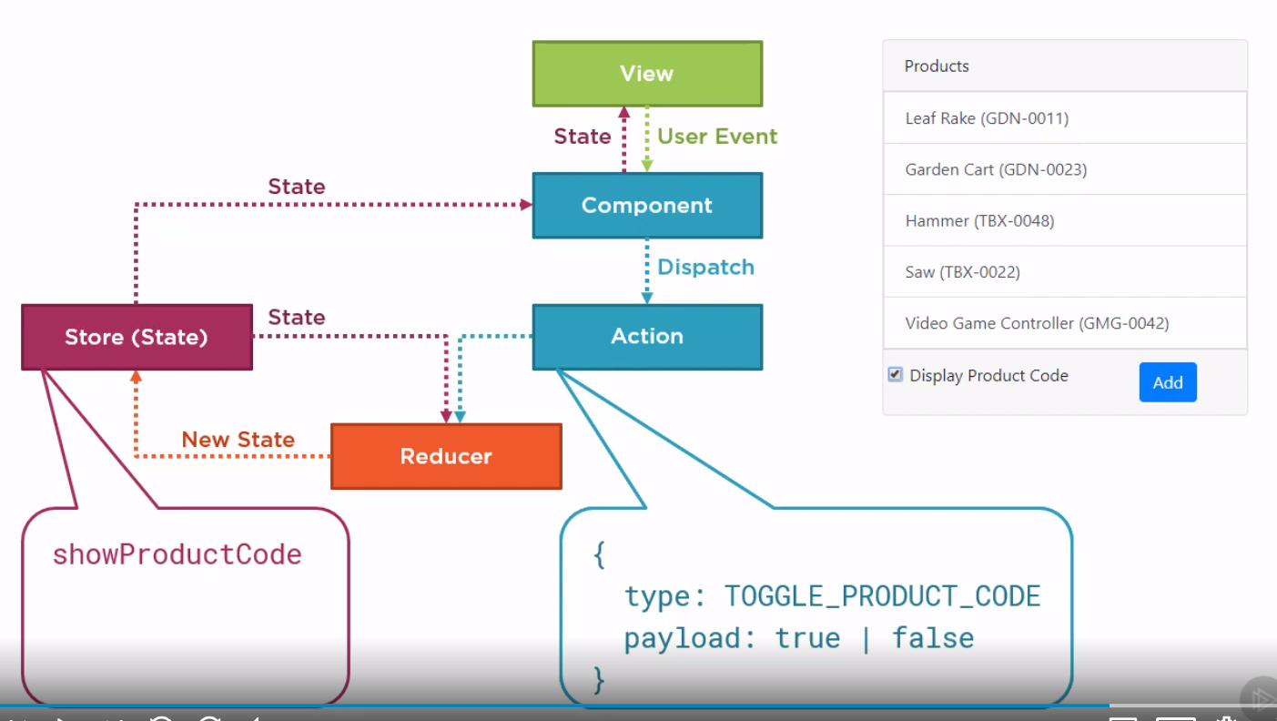

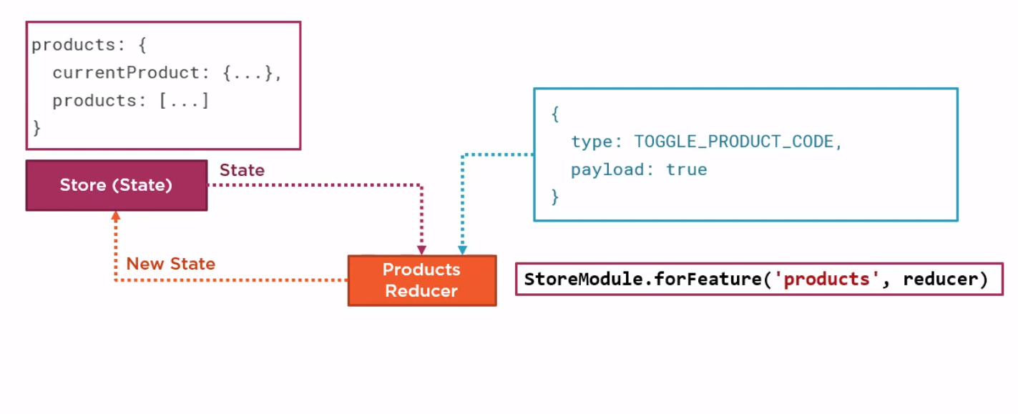

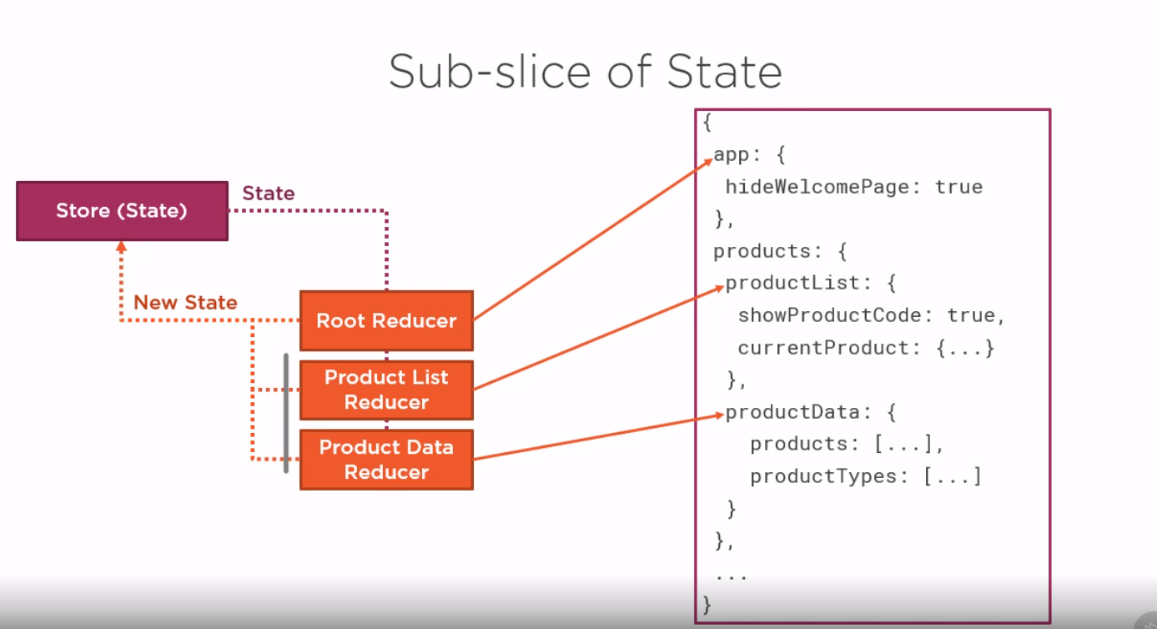

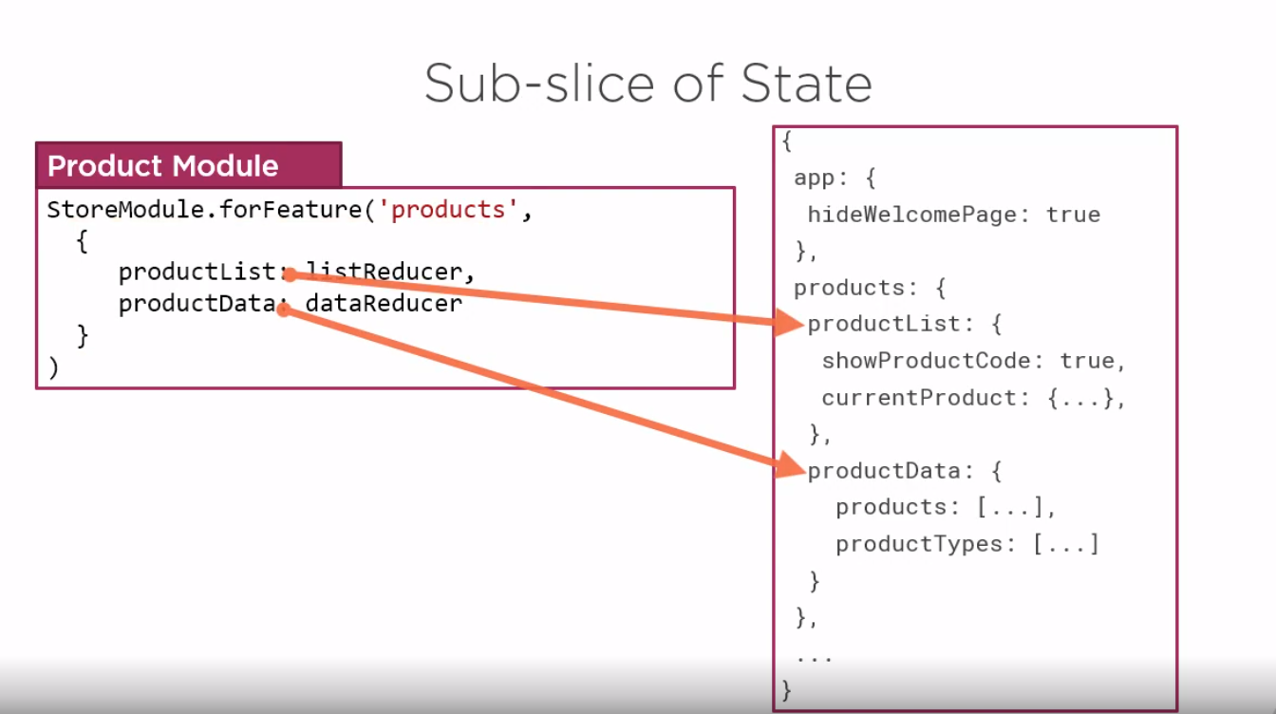

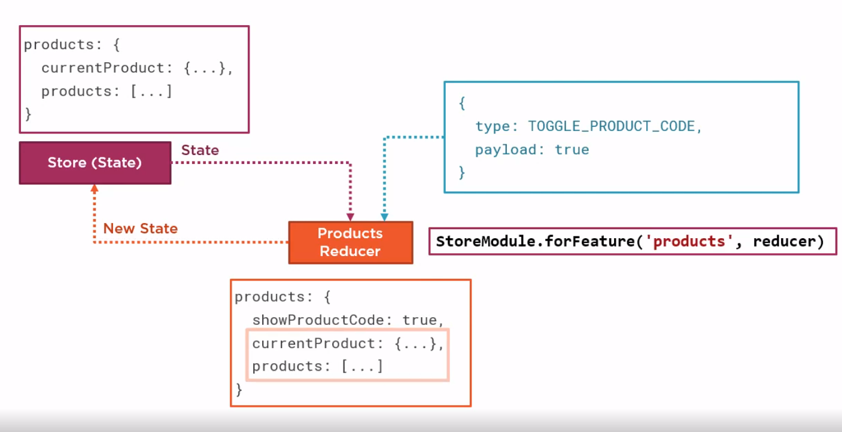

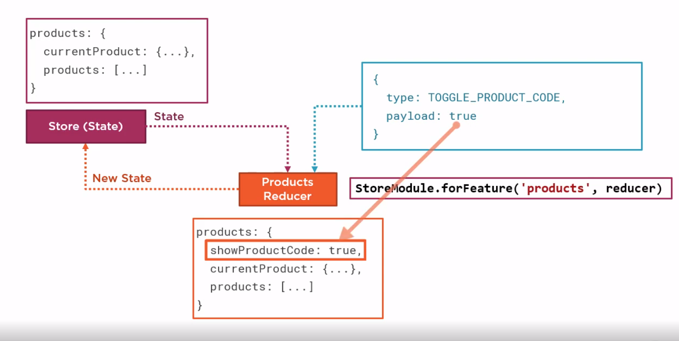

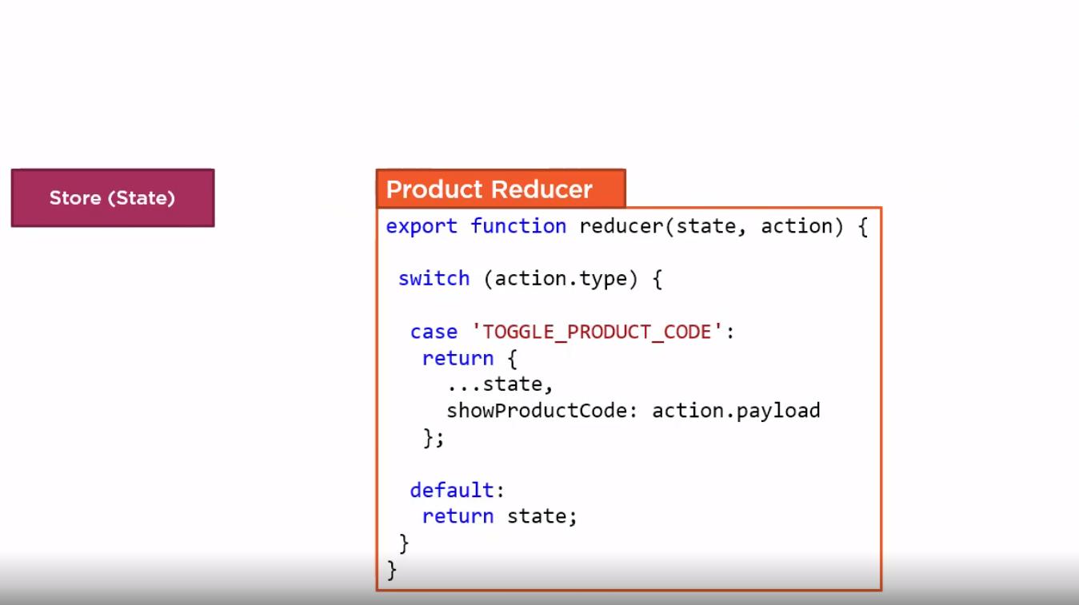

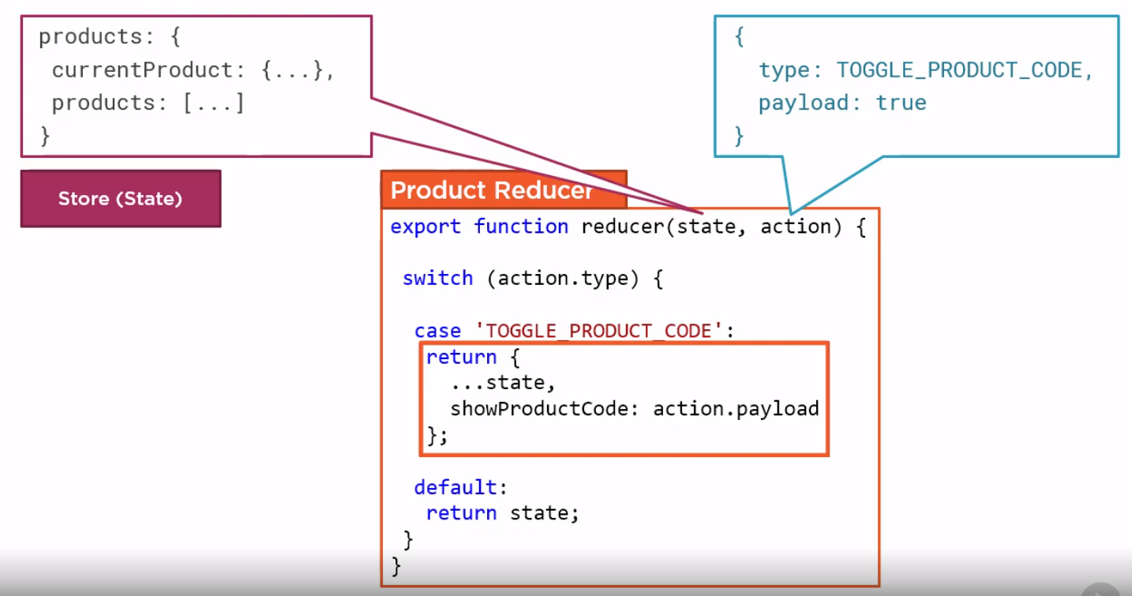

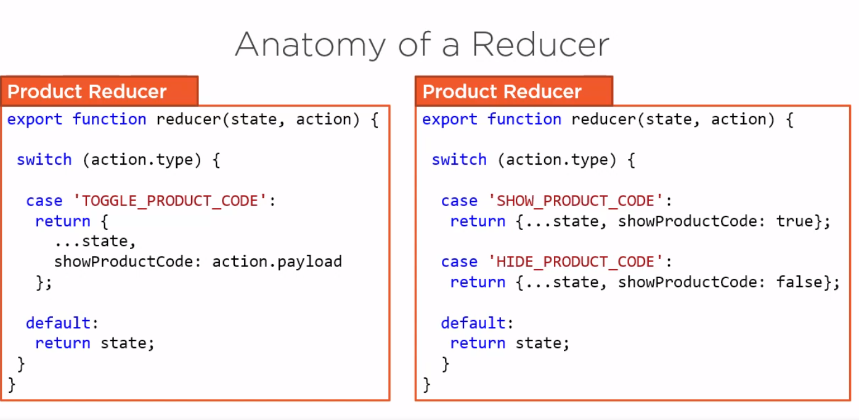

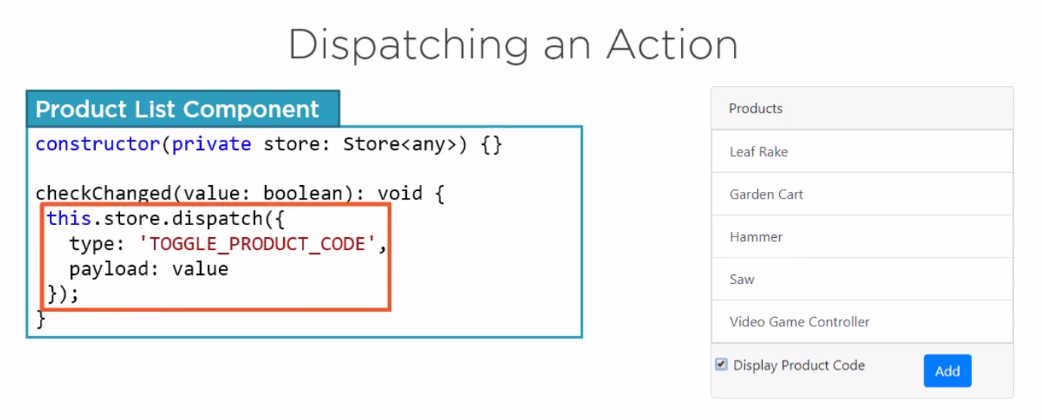

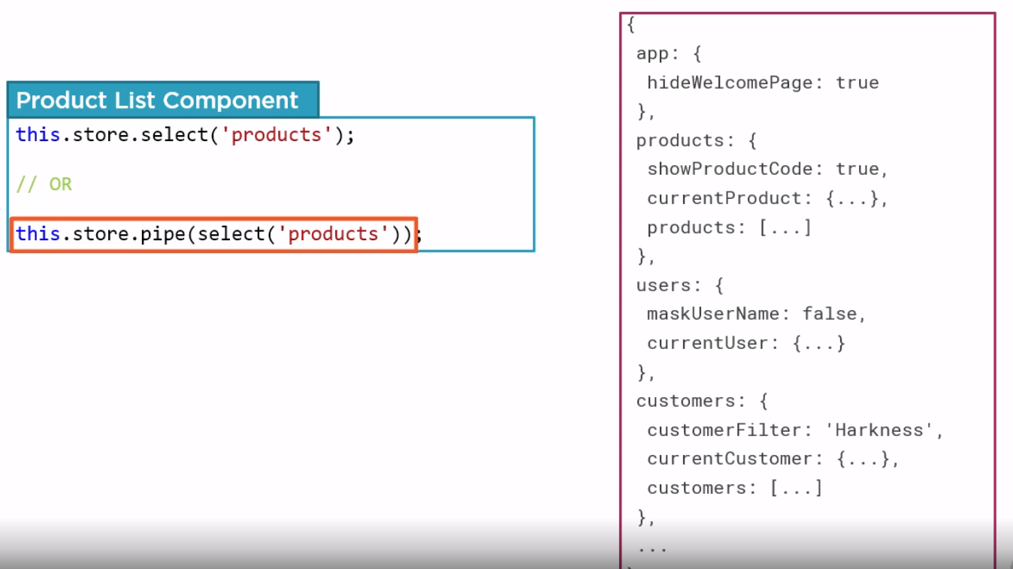

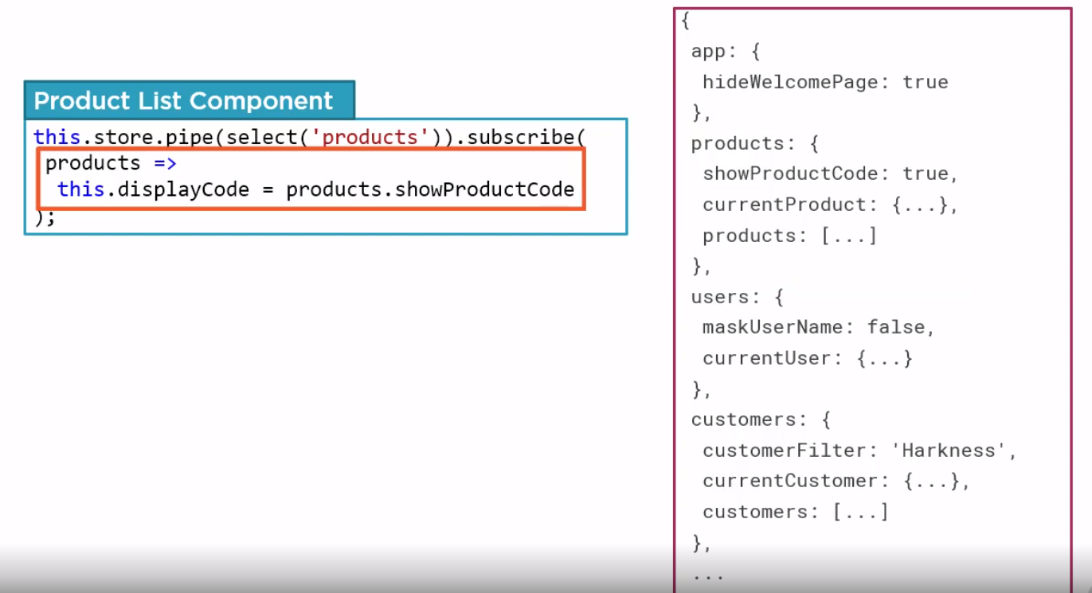

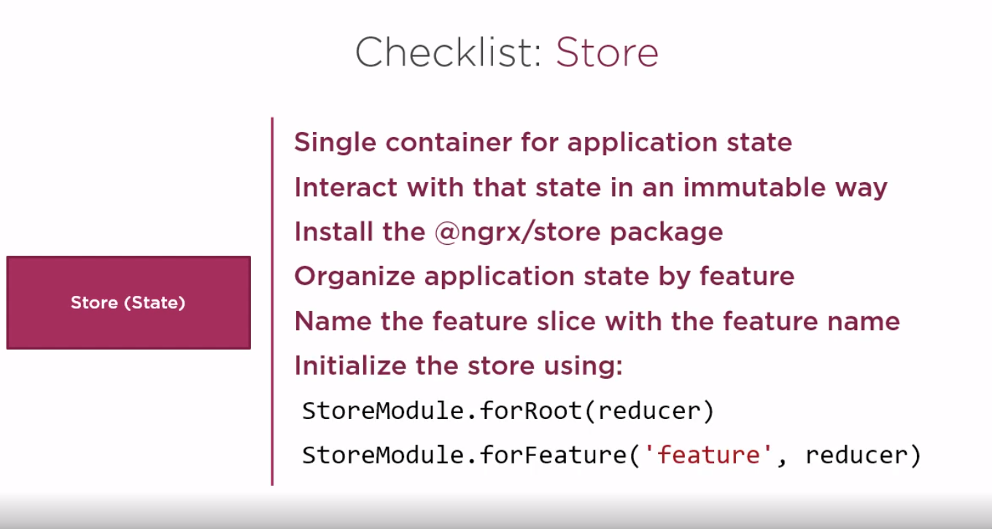

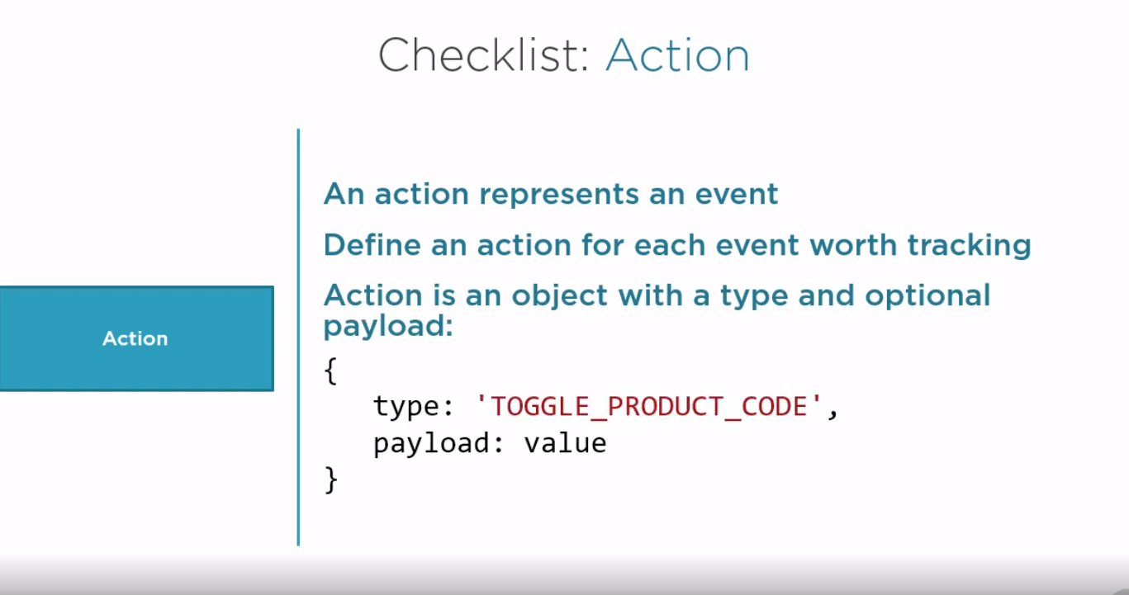

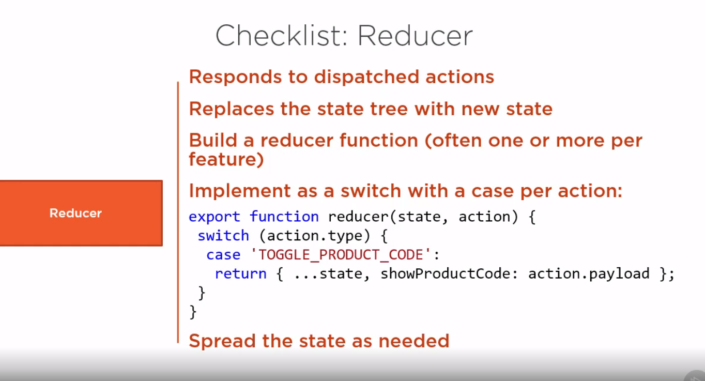

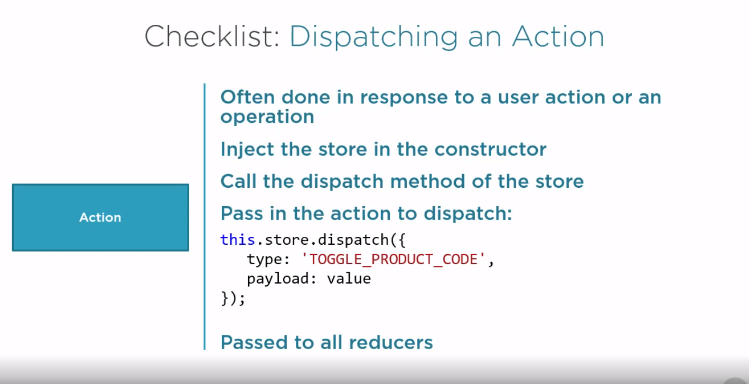

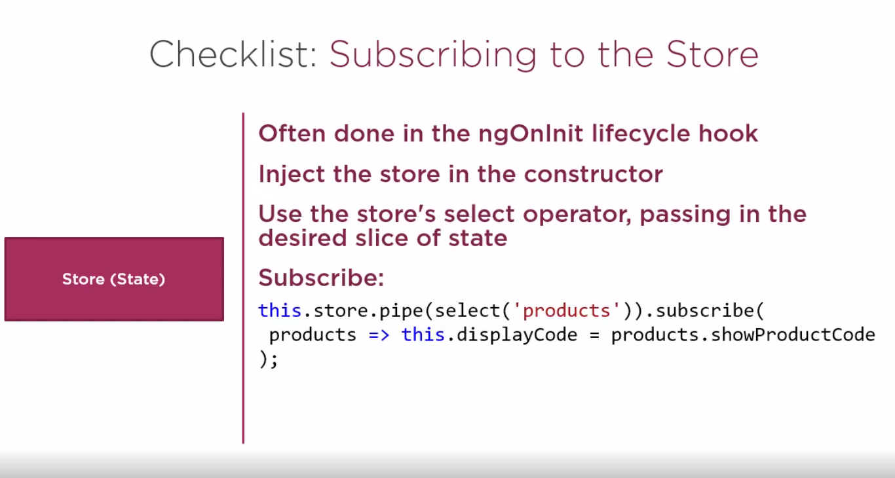

Steps to install reux devtools

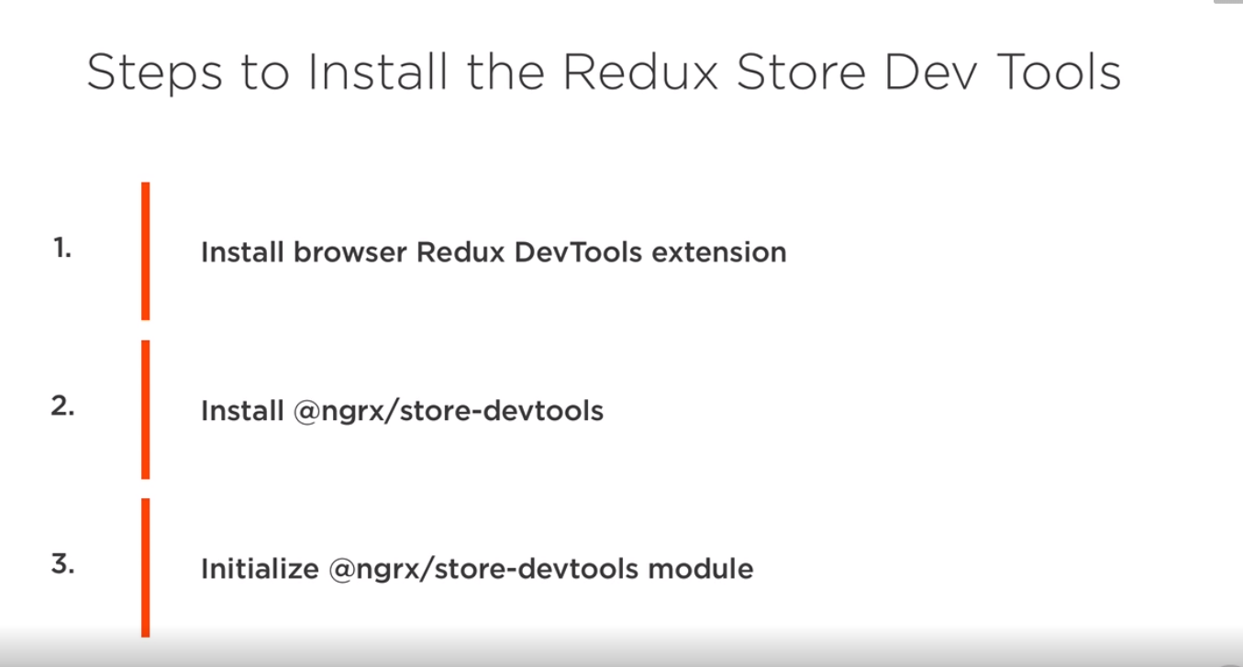

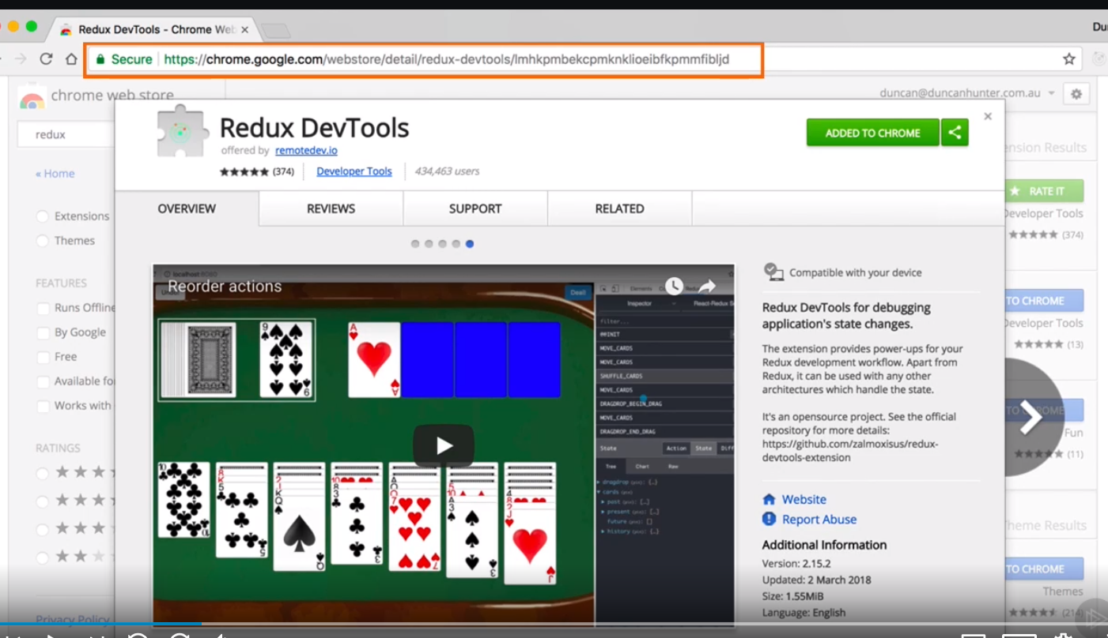

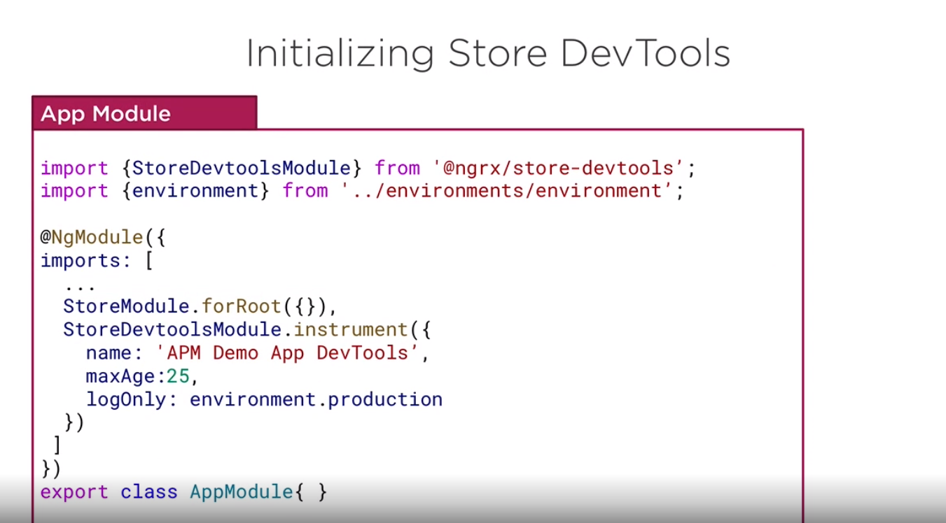

Installing

npm install @ngrx/store-devtools

First repo ends here

Adding strong typing state – repo \APM-Demo0.1

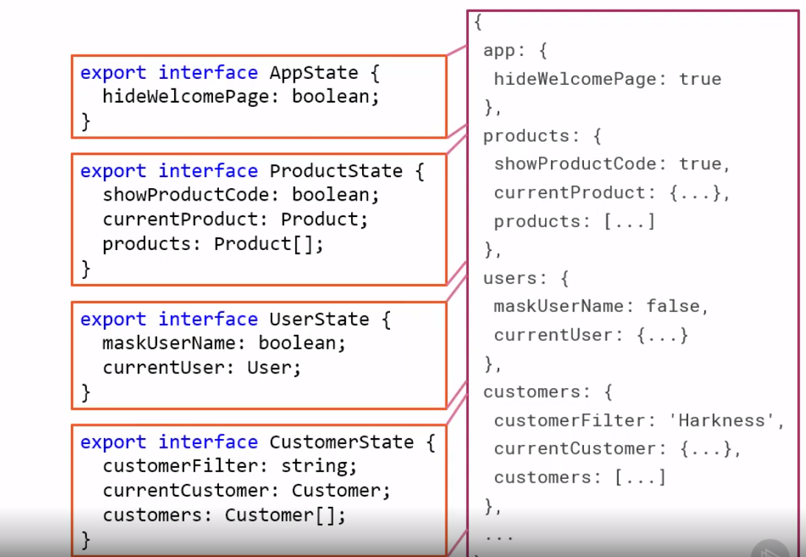

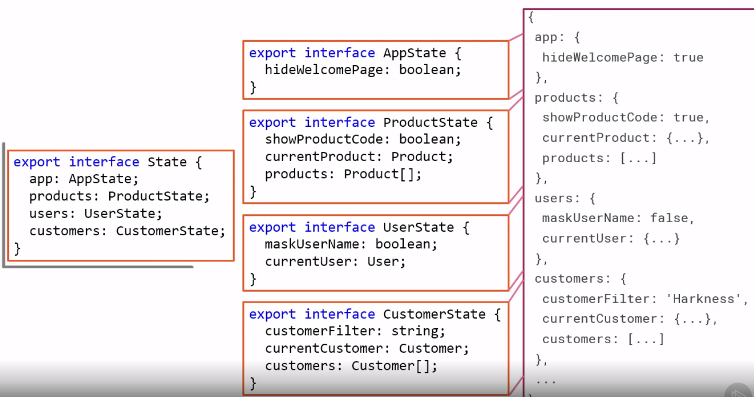

Defining main state named State in app, but problem with this implementation, is ProductState is lazy loaded we don’t want to inject anything from product state in main app this will break lazy loading.

So initially we will not add products in initial State interface as metioned in third step

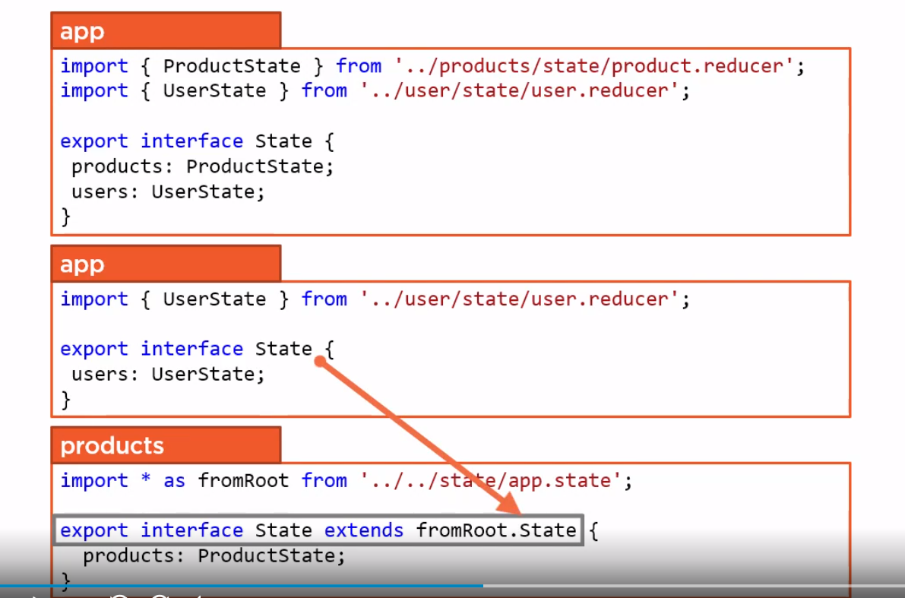

/*Subscribe to store

    When a component first subscribe a store it gets slice of selected state

    store is like a database i.e big object having all the state, with select we can select one of the state

    */

 this.store.pipe(select('products')).subscribe((products) => {

        if (products) {

          this.displayCode = products.showProductCode;

        }

    });

Setting initial value of state: We can initialize in reducer function

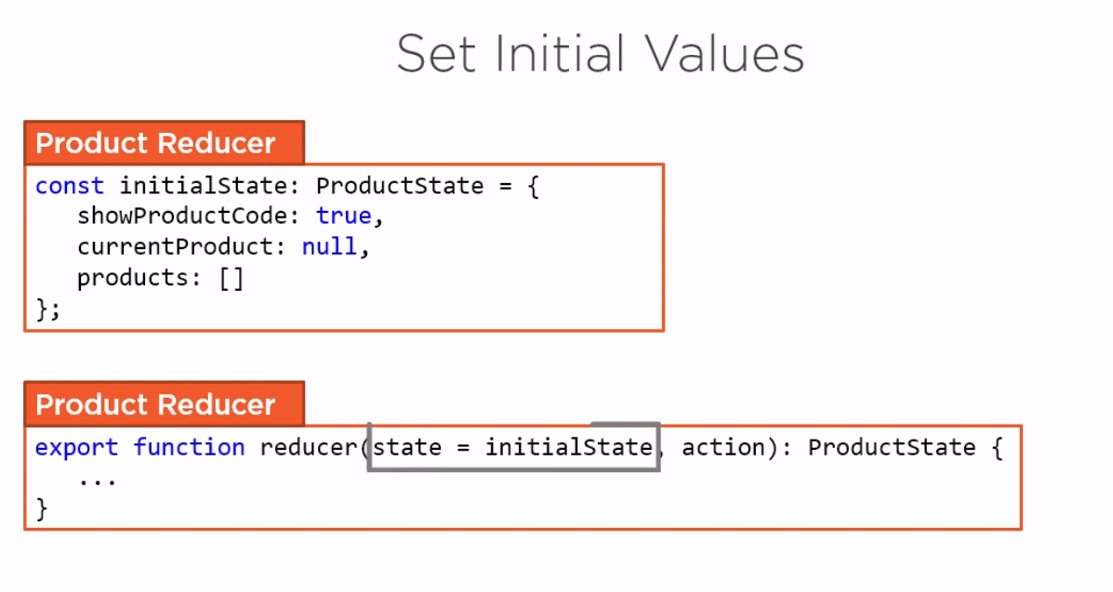

**Selectors**

**Components uses selectors to select state from store – Without selector, in a component we watches complete state that has performance impact if we want to watch only one element of state we can use seector**

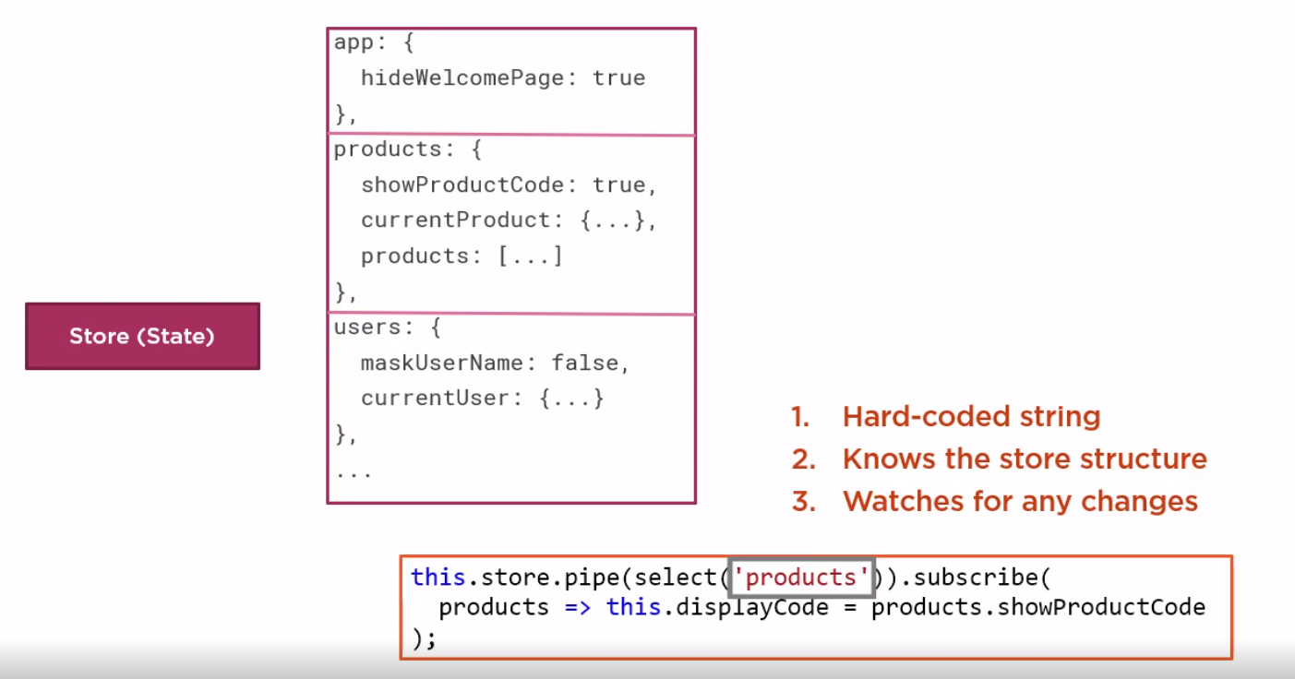

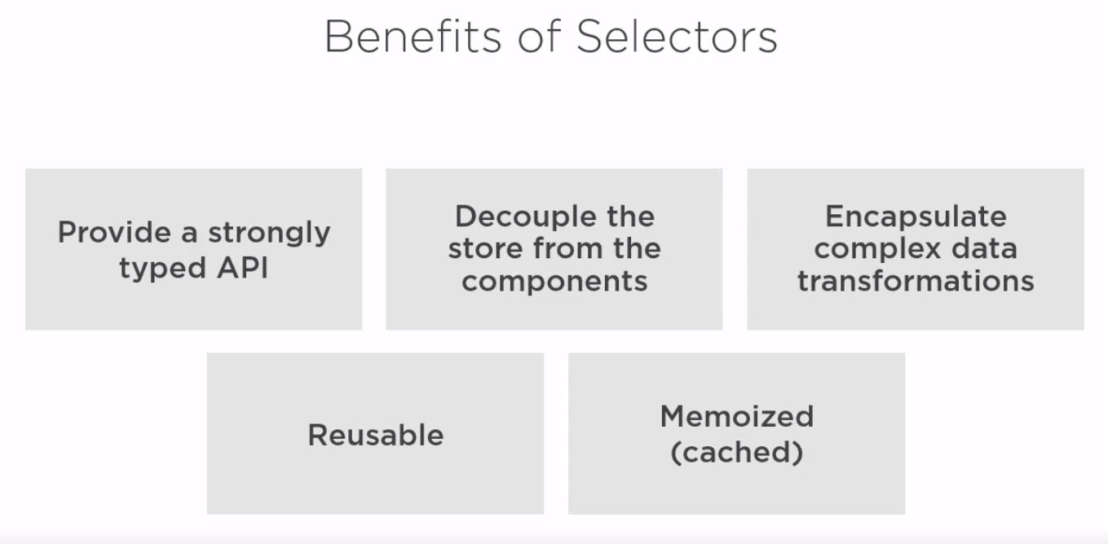

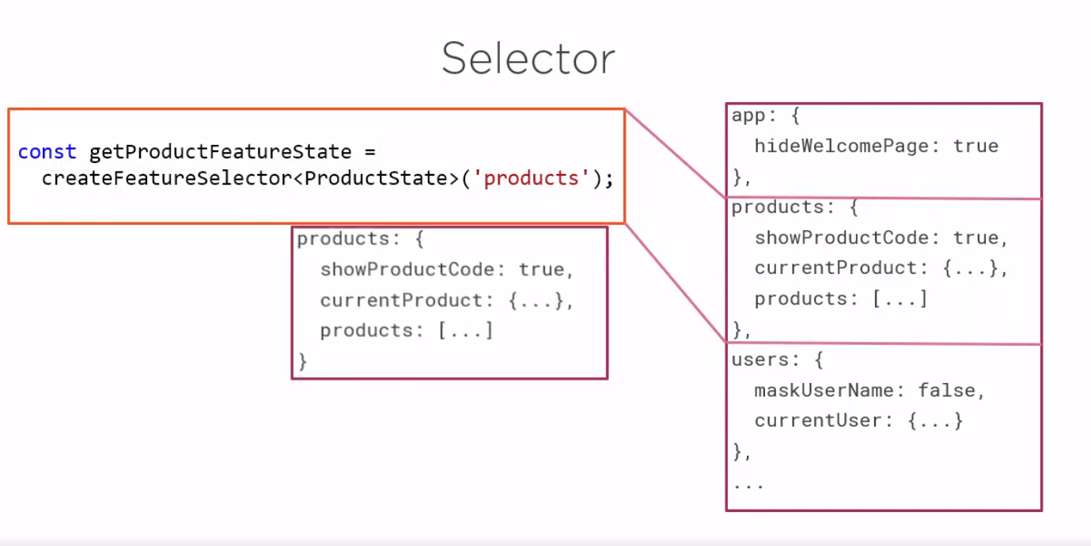

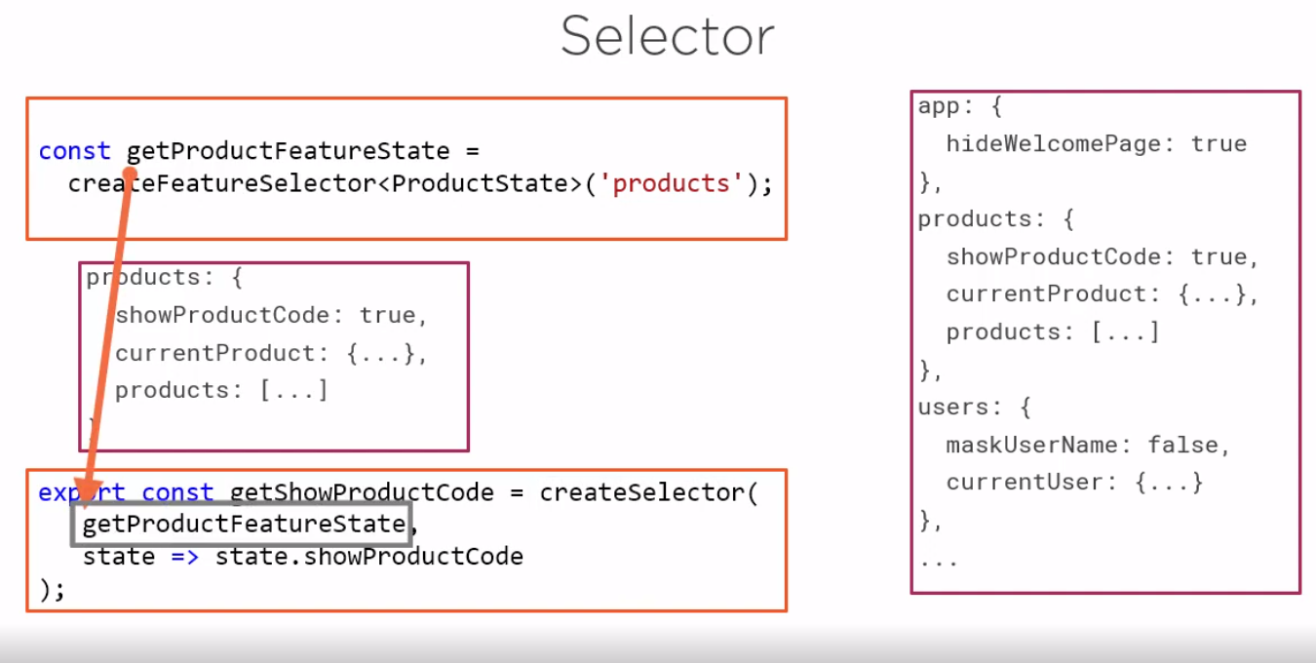

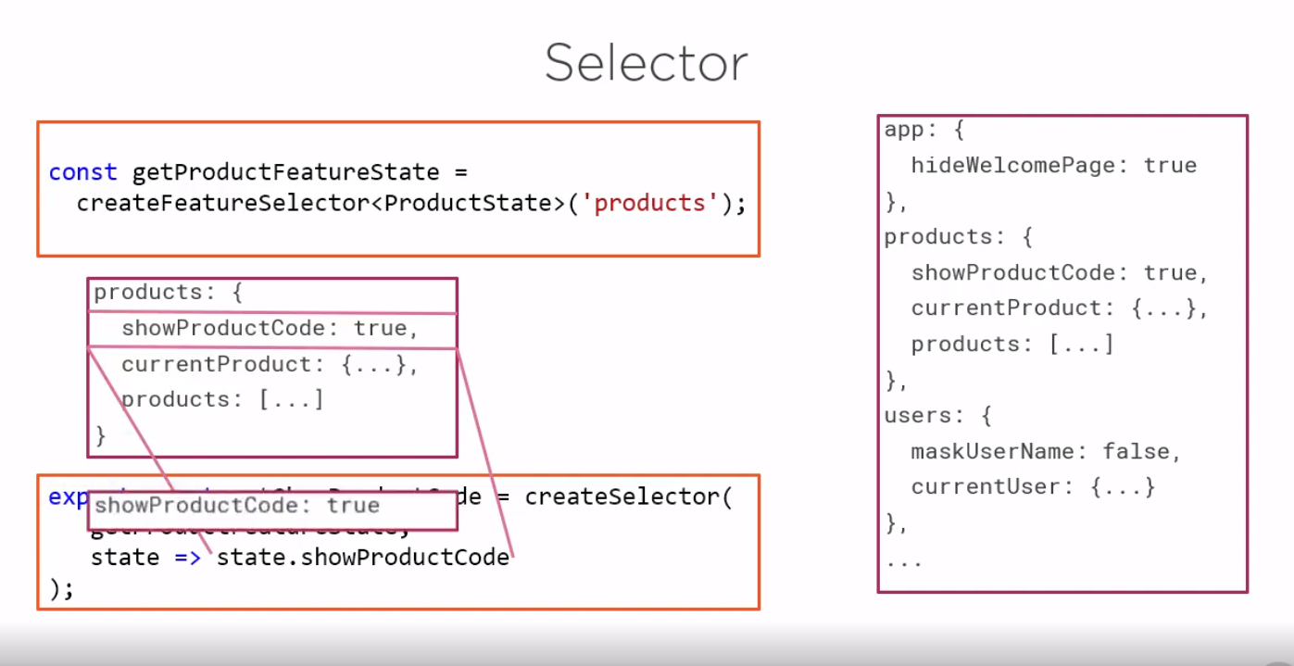

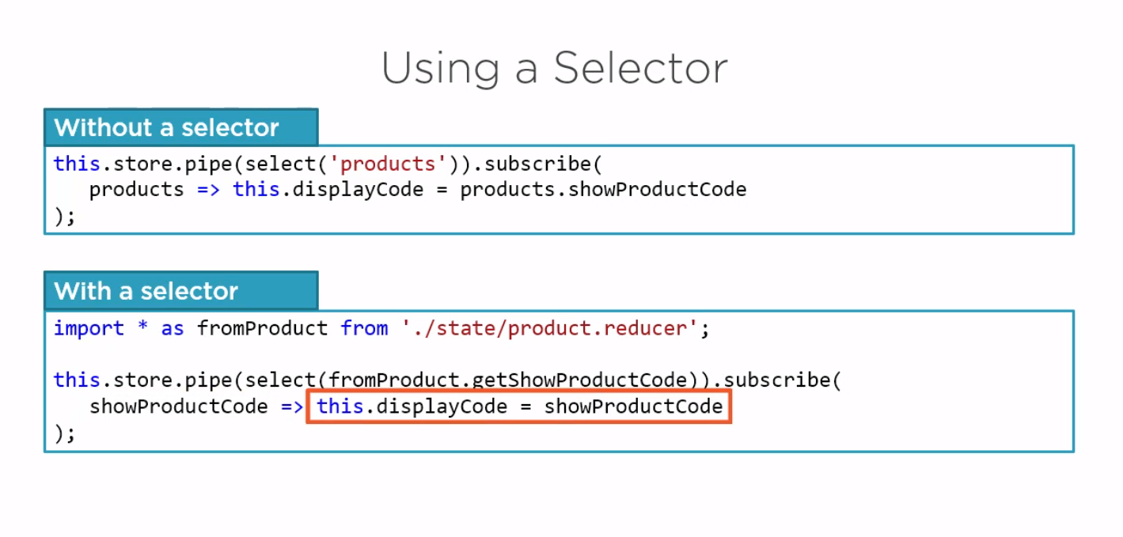

Selector is reusable query of our store

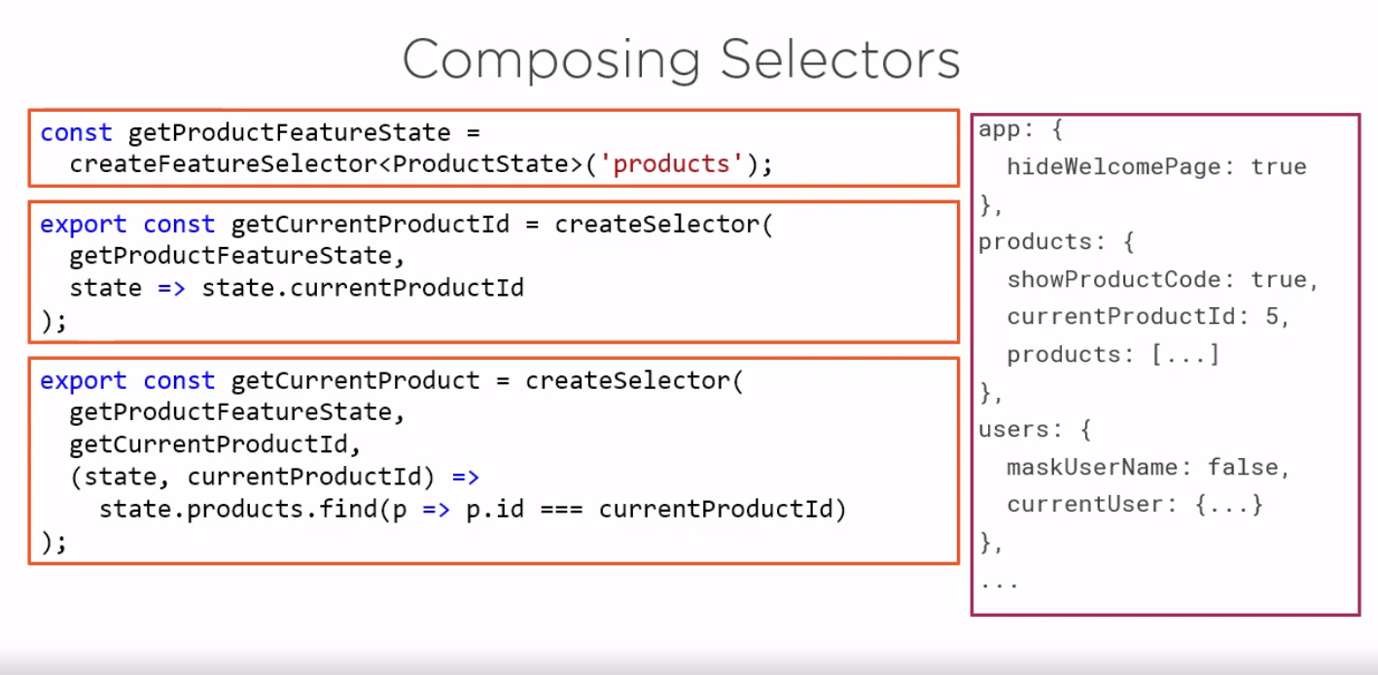

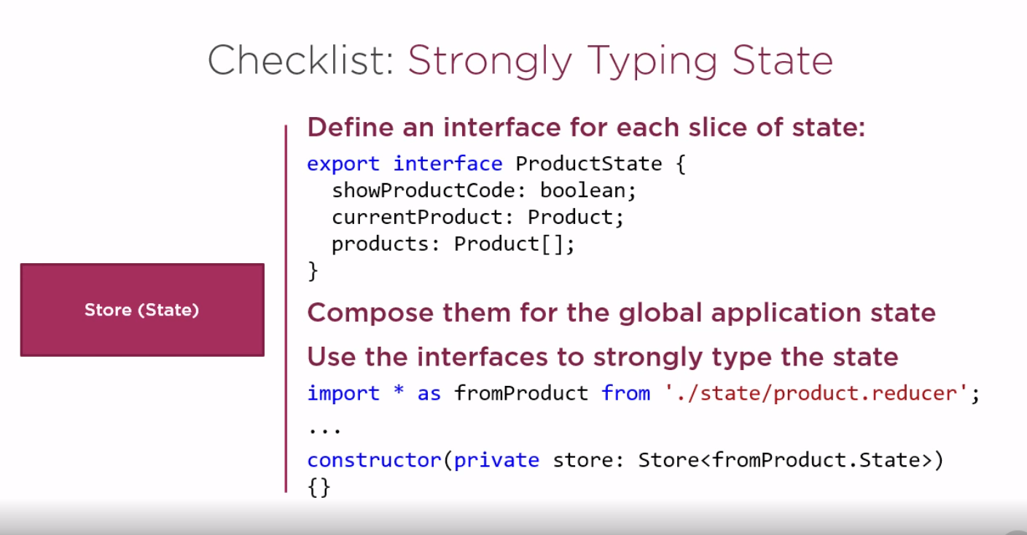

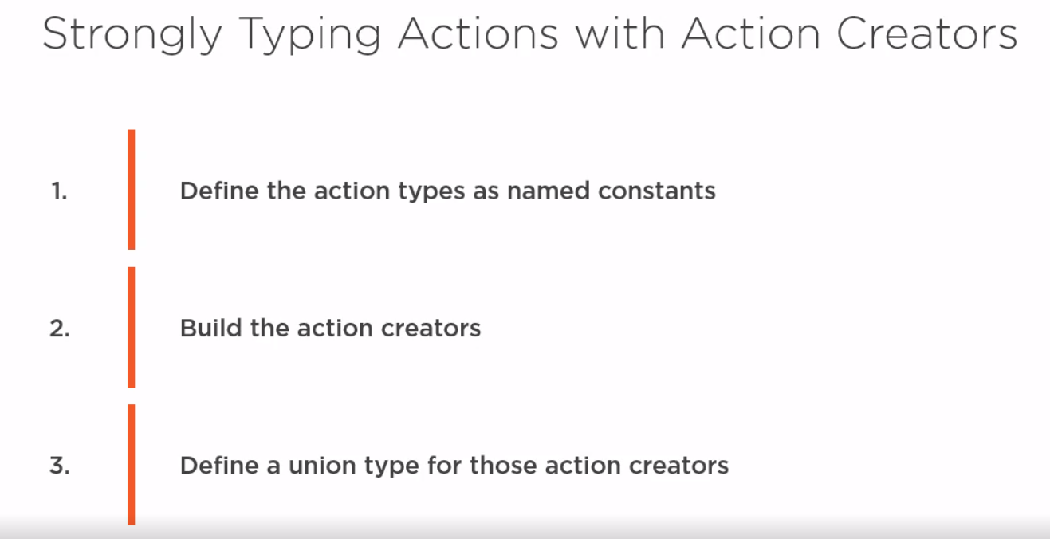

Performing action on complex item like fetching data from backend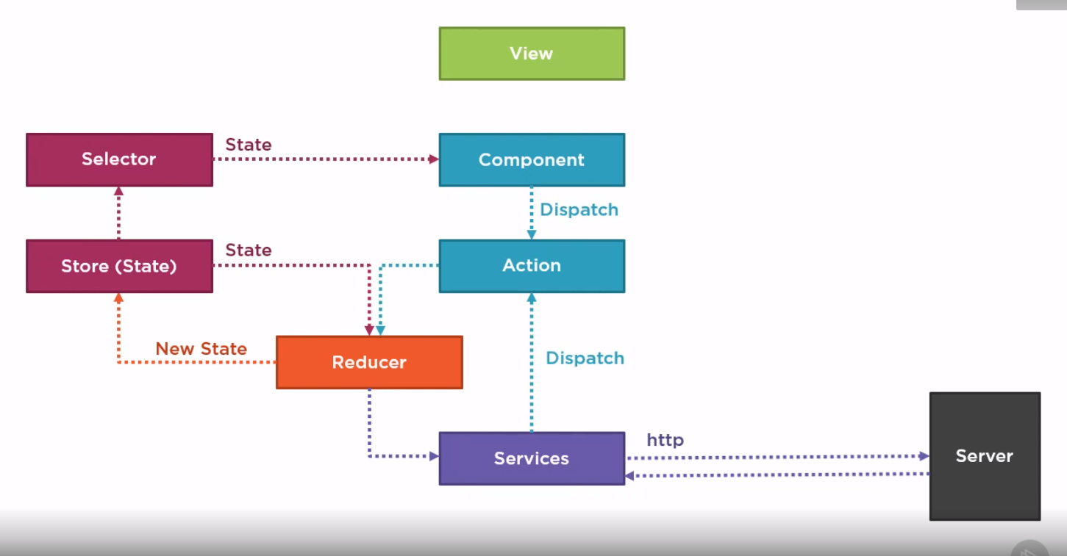

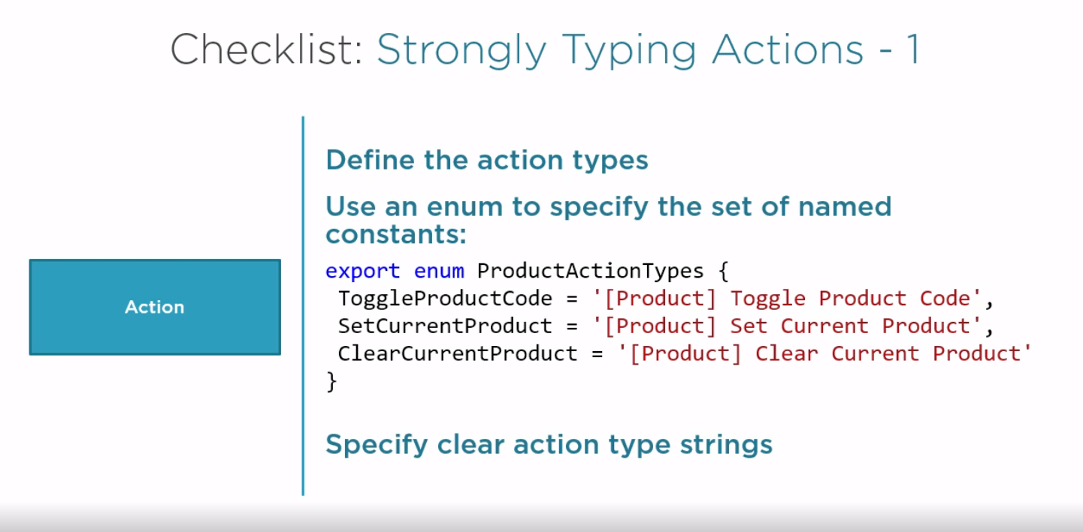

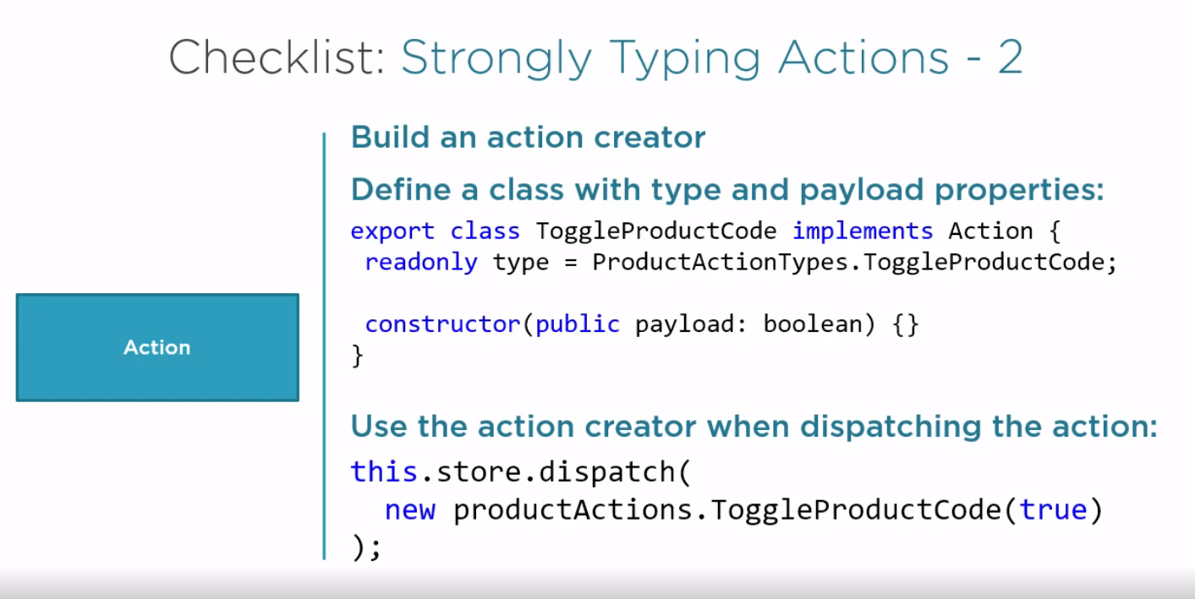

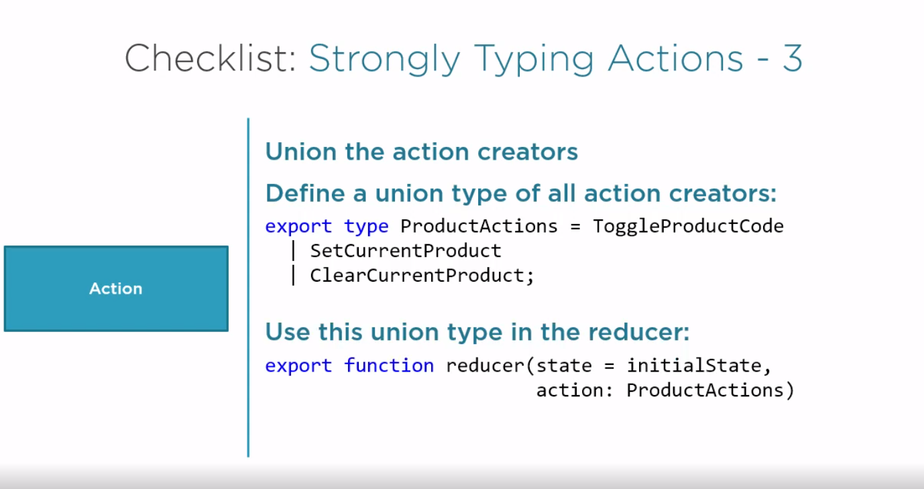

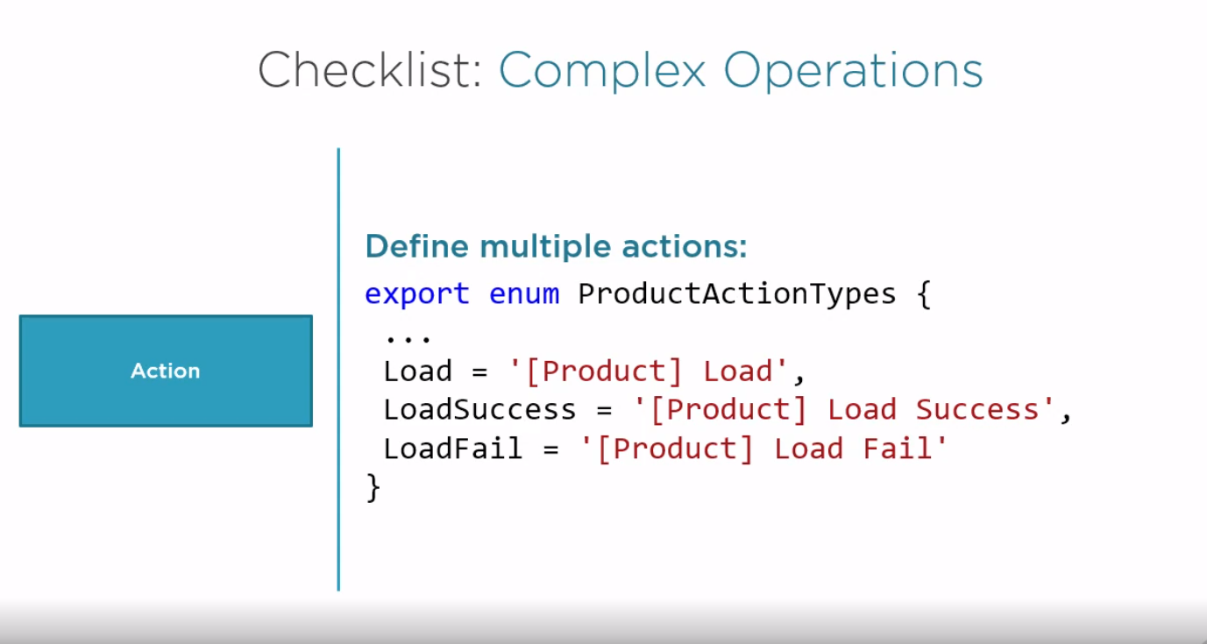

**Effects**

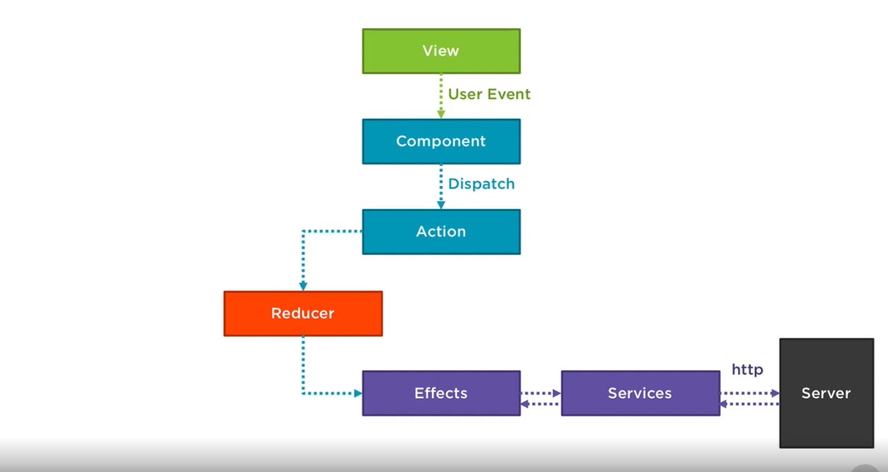

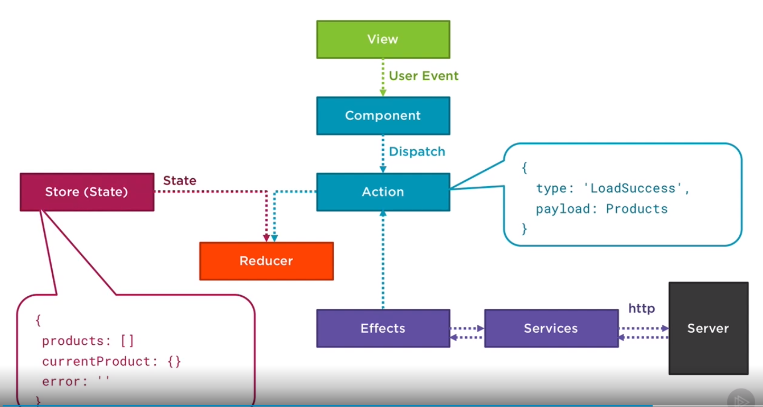

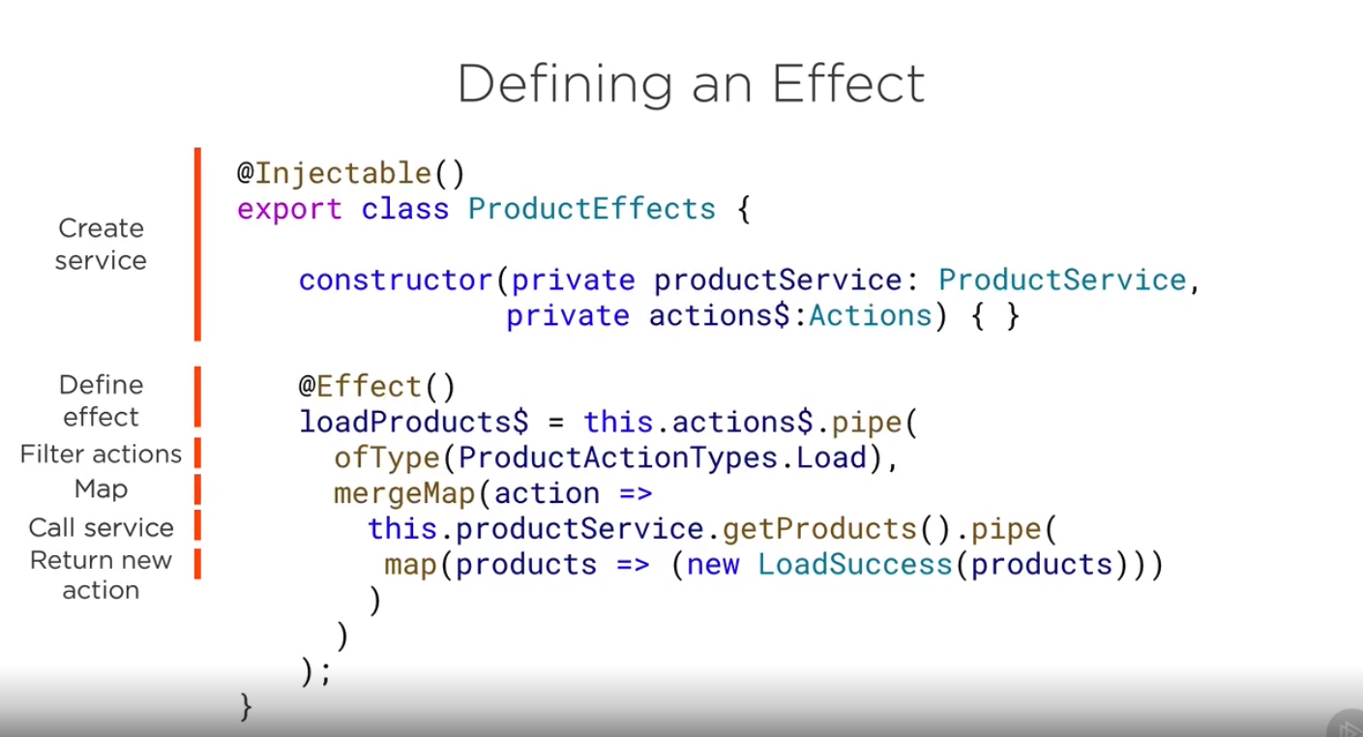

**npm install @ngrx/effects**

